

Semester One Examination, 2019

Question/Answer booklet

MATHEMATICS METHODS
UNIT 3

Section One:

Calculator-free

Your Name:
Your Teacher’s Name:

Time allowed for this section
Reading time before commencing work: five minutes
Working time: fifty minutes

Materials required/recommended for this section
To be provided by the supervisor
This Question/Answer booklet
Formula sheet

To be provided by the candidate
Standard items: pens (blue/black preferred), pencils (including coloured), sharpener, correction fluid/tape, eraser, ruler, highlighters

Special items: nil

Important note to candidates
No other items may be taken into the examination room. It is your responsibility to ensure that you do not have any unauthorised material. If you have any unauthorised material with you, hand it to the supervisor before reading any further.

Question | Marks | Max | Question | Mark | Max
1 |  | 6 | 5 |  | 6
2 |  | 6 | 6 |  | 10
3 |  | 8 | 7 |  | 10
4 |  | 6

Structure of this paper

Section | Number of questions available | Number of questions to be answered | Working time (minutes) | Marks available | Percentage of examination
Section One:  Calculator-free | 7 | 7 | 50 | 52 | 34
Section Two:  Calculator-assumed | 13 | 13 | 100 | 103 | 66
 |  |  |  | Total | 100

Instructions to candidates

- The rules for the conduct of the Western Australian Certificate of Education ATAR course examinations are detailed in the Year 12 Information Handbook 2019. Sitting this examination implies that you agree to abide by these rules.

- Write your answers in this Question/Answer booklet.

- You must be careful to confine your answers to the specific questions asked and to follow any instructions that are specific to a particular question.

- Additional pages for the use of planning your answer to a question or continuing your answer to a question have been provided at the end of this Question/Answer booklet. If you use the space to continue an answer, indicate in the original answer space where the answer is continued, i.e. give the page number.

- Show all your working clearly. Your working should be in sufficient detail to allow your answers to be checked readily and for marks to be awarded for reasoning. Incorrect answers given without supporting reasoning cannot be allocated any marks. For any question or part question worth more than two marks, valid working or justification is required to receive full marks. If you repeat any question, ensure that you cancel the answer you do not wish to have marked.

- It is recommended that you do not use pencil, except in diagrams.

- The Formula sheet is not to be handed in with your Question/Answer booklet.

Section One: Calculator-free (52 Marks)

This section has seven questions. Answer all questions. Write your answers in the spaces provided.

Spare pages are included at the end of this booklet. They can be used for planning your responses and/or as additional space if required to continue an answer.
● Planning: If you use the spare pages for planning, indicate this clearly at the top of the page.
● Continuing an answer: If you need to use the space to continue an answer, indicate in the original answer space where the answer is continued, i.e. give the page number. Fill in the number of the question that you are continuing to answer at the top of the page.

Working time: 50 minutes.

Question 1 (6 marks)

Differentiate the following with respect to x:

- $e^{x}sinsin (x^{2}+2)$ (2 marks)

Solution
Specific behaviours
✓ uses product rule
✓ differentiates sine term correctly with chain rule(no need to factorise)

- $\frac{coscos x }{x^{2}+5}$ (2 marks)

Solution
Specific behaviours
✓ uses quotient rule(or appropriate product rule)
✓ differentiates cosine term

- (2 marks)

Solution
Specific behaviours
✓ uses fundamental theorem
✓ obtains correct expression

Question 2 (6 marks)

“Blood flow” is defined as the volume $V$ of blood flowing through an artery per unit of time. It can be modelled by the formula $V=kr^{3}$, where $r$ is the radius of the artery and $k$ is a constant.

- By what fraction is the blood flow in the artery reduced when its radius is halved?
(2 marks)

Solution
Reduced by

Specific behaviours
✓ cubes one half
✓ states

- Use the incremental formula to estimate the percentage increase required in the radius of a partially clogged artery to produce a 6% increase in the blood flow. (3 marks)

Solution
Specific behaviours
✓ uses incremental formula
✓obtains expression for change in Volume/Radius
✓ obtains percentage change in radius(accept 0.02)

- Explain why the incremental formula does not give a good estimate for the change in $V$ in part (a). (1 mark)

Solution
which is too large
Incremental formula only useful for small percentage changes

Specific behaviours
✓ states reasonable explanation

Question 3 (8 marks)

Determine the following:

- $\frac{d}{dx}(e^{2x}sinsin 3x )$ (2 marks)

Solution
Specific behaviours
✓ uses product rule
✓ diff sine term with chain rule(no need to factorise)

- $\frac{d}{dx}(e^{2x}coscos 3x )$ (2 marks)

Solution
Specific behaviours
✓ uses product rule
✓ diff cosine term with chain rule(no need to factorise)

Hence, determine the following integral by considering both expressions above.

- $\int_{0}^{\frac{π}{2}}{}13e^{2x}coscos 3x dx$ (4 marks)

Solution
Specific behaviours
✓ modifies derivatives in a & b by multiplying by factors 2 & 3
✓ obtains an equivalent expression of integral in terms of two derivatives
✓ uses fundamental theorem
✓obtains exact value for integral

Question 4 (6 marks)

The amount of pollution, $P$, in tonnes, to build $x$ thousands number of transistors by an electronic manufacturer, is given by the following formula:

$P\left(x\right)=\frac{e^{x}}{x^{3}}$

where $0<x≤5.5$ thousands.

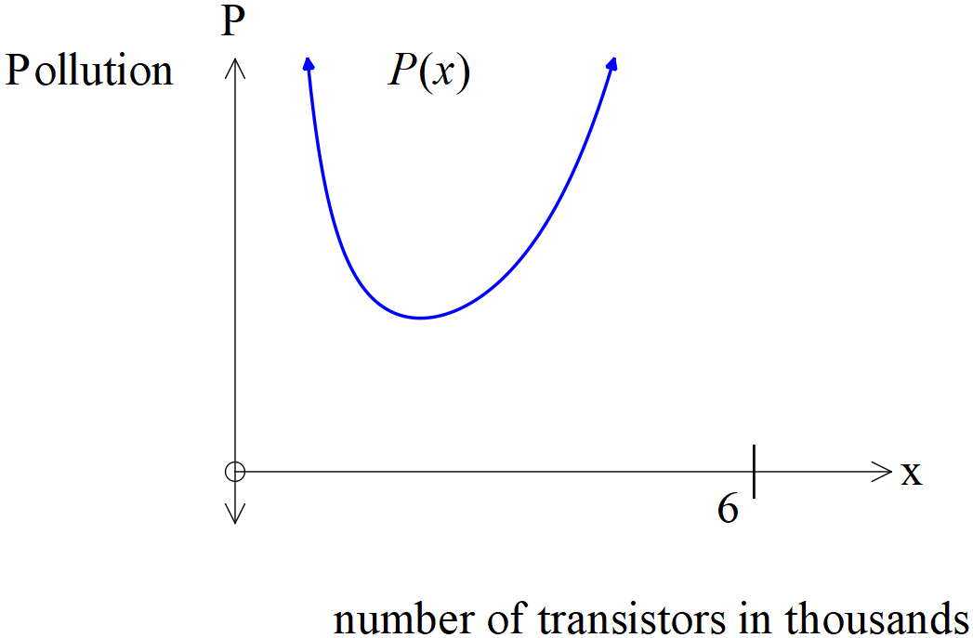

(a) Describe how the pollution changes as the number of transistors made, varies from
$0<x≤5.5$ thousands. (2 marks)

Solution
Pollution is initially very high but then decreases to a minimum value before then increasing again.

Specific behaviours
✓ initially high
✓ reaches a minimum then increases

(b) Using calculus, determine the number of transistors that will minimize the pollution produced. (4 marks)

Solution
Therefore x=3 is a local minimum

3000 transistors will minimize pollution
Specific behaviours
✓ uses quotient rule(or appropriate product rule)
✓ equates derivative to zero and solves for x
✓ uses first derivative sign test (or second)
✓ states in thousands the number to minimize pollution

Question 5 (6 marks)

Twenty teachers have been marking the same set of exam papers and after double checking it was found that the teachers made the following number of errors,
1, 1, 3, 1, 4, 4, 1, 3, 5, 1, 2, 2, 4, 4, 5, 0, 6, 5, 5, 5.

Let $X=$ the number of errors of a teacher.

(a) Construct a table that defines the probability distribution of $X$. (3 marks)

Solution
x | 0 | 1 | 2 | 3 | 4 | 5 | 6
P(X=x)

Specific behaviours
✓ correct values of x
✓ uses frequencies
✓ states probabilities(no need to simplify)

(b) Use the probability distribution above to show how to evaluate the expected value of $X$. State this value. (3 marks)

Solution
Specific behaviours
✓ multiplies x by probability
✓ sums the above
✓states the expected value, no need to simplify.

Question 6 (10 marks)

In a shop an average of 1 out of 5 pay with cash, 3 out of every 5 customers use a credit card, and the rest use a debit card to pay. A single customer is selected from the store.The random variable $X$ is defined as the number of customers who pay with cash.

- Complete the probability distribution for $X$ shown below. (2 marks)

Solution
$x$ | $0$ | $1$
$P(X=x)$

Specific behaviours
✓ determines for x=0
✓ determines for both variables

- State the distribution of $X$. (1 mark)

Solution
A Bernoulli distribution

Specific behaviours
✓ states Bernoulli

- Determine the mean and standard deviation of the distribution. (2 marks)

Solution
Mean =
Standard deviation =

Specific behaviours
✓ states the mean
✓ states the simplified standard deviation

Four customers are waiting in a queue to pay. The random variable $Y$ is defined as number of customers from this queue who pay with credit card.

- State the distribution of $Y$, including its parameters. (2 marks)

Solution
Specific behaviours
✓ states Binomial
✓ states both parameters

- Evaluate the probability of at most one customer paying with credit card.
(No need to simplify)
(3 marks)

Solution
Specific behaviours
✓ uses Y=0, Y=1 only
✓ uses binomial formula
✓ derives an expression for the sum of these two probabilities

Question 7 (10 marks)

Consider a smooth and continuous function $f(x)$ where $f\left(-5\right)=0=f\left(0\right)=f\left(7\right)=f(10)$ , and . It is known that $f\left(x\right)≥0$ for $-5≤x≤0$ and $7≤x≤10$ with for all other values. It is also given that $\int_{-5}^{10}{}f(x)dx=19$ and $\int_{0}^{7}{}f(x)dx=-6$ and $\int_{7}^{10}{}f(x)dx=15$.

Determine the following:

(a) $\int_{-3}^{4}{}f'(x)dx$ (2 marks)

Solution
Specific behaviours
✓ uses fundamental theorem
✓ determines integral

(b) $\int_{-5}^{7}{}f(x)dx$ (2 marks)

Solution
Specific behaviours
✓ uses linearity for integrals(addition or subtraction)
✓ determines final integral

(c) the stationary points of $g(x)$ given that $g\left(x\right)=\int_{-5}^{x}{}f(t)dt$ with $-5≤x≤10$ (3 marks)

Solution
Specific behaviours
✓ uses fundamental theorem
✓ equates f(x) to zero
✓solves for all 4 stationary points

It is known that for and for .
- Determine the area under the curve from . (3 marks)

Solution
Specific behaviours
✓ divides into two intervals with absolute value for one interval
✓ uses fundamental theorem
✓calculates area

End of Questions
Additional working space
Question number: ________

